EMPLOYING PERSONS WITH DISABILITIES
a resource book for employers



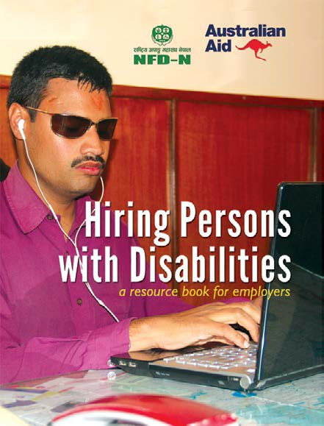

EMPLOYING PERSONS WITH DISABILITIES

a resource book for employers

Authors: Sagar Prasai, Bishal Dahal, Manish Prasai and Kishor Rijal
Advisor: Shudarson Subedi
Language Editor: Shraddha Pokharel

On Cover:
Front: Sushil Adhikari, a visually impaired person, working in his office.
Front-Inner: Prem Acharya (left) and Kirtan Duwal talking during their work recess. Back: Yami Magar (in wheelchair) talking to her supervisor.
Back-Inner: Madhav Subedi wheeling his wheelchair on a ramp.

Publisher:
National Federation of Disabled-Nepal Bhrikutimandap, Kathmandu, Nepal PO Box no. 9188
Phone: +977-1-4231159
Fax: +977-1-4229522
Email: info@nfdn.org.np Web: www.nfdn.org.np

Layout: Yogesh Khapangi, 9843274745
Cover Photos: Tirtha Maharjan, 9840050082
Printers: Bhojpur Siddhakali Printing Press, 9851098800
ISBN : 978-9937-0-0222-6
First Edition: August, 2016
© All Rights Reserved
An electronic copy of this book can be downloaded from http://www.nfdn.org.np



6 October 20 l 5

Congratulatory message
AUSTRALIAN EMBASSY KATHMANDU


AMBASSADOR

I congratulate the National Federation of Disabled Nepal (NFDN) for its initiative in publishing a handbook which will prove useful to institutions considering employment of people with special needs.
Inclusion in the workforce is a major issue needing to be addressed through creation of accessible workplaces and this initiative will not only improve the employment opportunities of persons with disabilities but also create awareness among employees on the benefits of having a diverse workforce.
The Embassy welcomes the opportunity to fund the NFDN to upgrade its office and help develop this manual through the Embassy's Direct Aid Program 2014.


Australian Embassy, P.O. Box 879, Bansbari, Kathmandu , NEPAL Telephone: 977 I 4371 678 Facsimile : 977 I 4371 533 Website: www.nepal.embassy .gov. au

Congratulatory Note

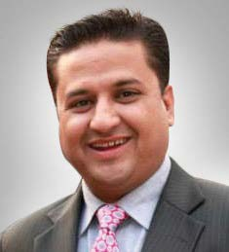

I congratulate the National Federation of Disabled Nepal (NFDN) for a won- derful initiative in publishing a guideline handbook to encourage recruiting persons with disabilities and create an impact in the society and the nation.

meroJob.com, a leading jobsite in Nepal since 2009, has been very positive for inclusion in the workforce and has co-sponsored Job Fair in collaboration with NFDN for three consecutive years since 2012. We also hired two persons with disabilities in the organization to start the initiation and provided space for such workforce in the ‘HIRE ME’ section of the website. We have also been orienting HR manag- ers of different organizations on advantages of workforce diversity.

Being in the HR industry for over a decade and half and with a keen per- sonal interest, I was always commited for inclusion of persons with disabili- ties in the workforce to increase productivity and to motivate them as well.

I see this handbook as a good resource to HR managers and professionals in creating employment opportunities for persons with disabilities with awareness on the benefits of workforce diversity.

Shailendra Raj Giri Managing Director Real Solutions Pvt. Ltd
http://www.merojob.com

Message from the President



“States Parties recognize the right of persons with disabilities to work, on an equal basis with others; this includes the right to the opportunity to gain a living by work freely chosen or accepted in a labour market and work environment that is open, inclusive and accessible to persons with disabilities”

– UN Convention on the Rights of Persons with Disabilities (UNCRPD), Article 27.

espite having lots of capacity and potentials persons with disabilities are often excluded from employment sectors. Many barriers hinder our access in the labor market and force us to live financially inactive.
D
Unfriendly physical infrastructure, transportation, communication and information services, lack of reasonable accommodation in work station, inadequate legal provision, ignorance in hiring process, lack of knowledge and ideas among the employers to address the special needs of persons with disabilities in job, low conviction of employers in the capacity and productivity of persons with disabilities are the key barriers that isolate us from mainstream employment sector and labor market. But it is also the fact that exclusion of workforce from the productive sector or market is not only a social issue but rather a huge economic loss for the country.

It has been globally accepted that persons with disabilities are not the subject of sympathy and charity but are the new work force and consumer segment of market. Unfortunately this is not activated due the

aforementioned barriers. In Nepal’s context, NFDN’s concern is to equip this force and include them in the market as a productive citizen, active consumer and contributor of society as well.

NFDN has been carrying out various activities for promoting the rights to work of persons with disabilities such as survey, research, career expo, career counseling, interaction and lobbying with employers, advocacy and lobbying with government and so on. NFDN has observed a significant gap among the employers in understanding disability, identifying the capacity of persons with disabilities, addressing their special needs and ensuring accessibility and reasonable accommodation in work place. We thought that, this gap should be narrowed gradually and a very professional relationship between employers and work force with disabilities should be established.

To address this issue NFDN has put forth the idea of this publication . Through this publication we are trying to increase the knowledge and understanding of our employers about disability in general, factors to be considered before and after hiring persons with disabilities, identifying barriers and ways for solving it, accessibility issues to be addressed, behavioral issues to be managed and attitudinal problems to be avoided in workplace, management and overall labor market.

I believe that, this small attempt would help our employers to develop a good level of confidence in them to provide employment to persons with disabilities. We always expect and welcome your creative feedback and suggestions to make our work more effective.

Finally I would like to extend my thanks to the Australian Embassy for its financial support to develop and publish this book and the entire project team of NFDN who used their professional skills and knowledge to make this possible.

Thank you !



Shudarson Subedi
National President National Federation of the Disabled Nepal

Content

- Introduction | Page 1

Why is it a Good Idea to Hire Persons with Disabilities? | Page 3
  - Cost of Exclusion | Page 11

Hiring Persons with Disabilities: The Process | Page 13
  - Post Hiring : Managing Employees with Disabilities | Page 21
  - Miscellenous | Page 31

Understanding Disabilities | Page 35
- Additional Resources | Page 39
- References | Page 40

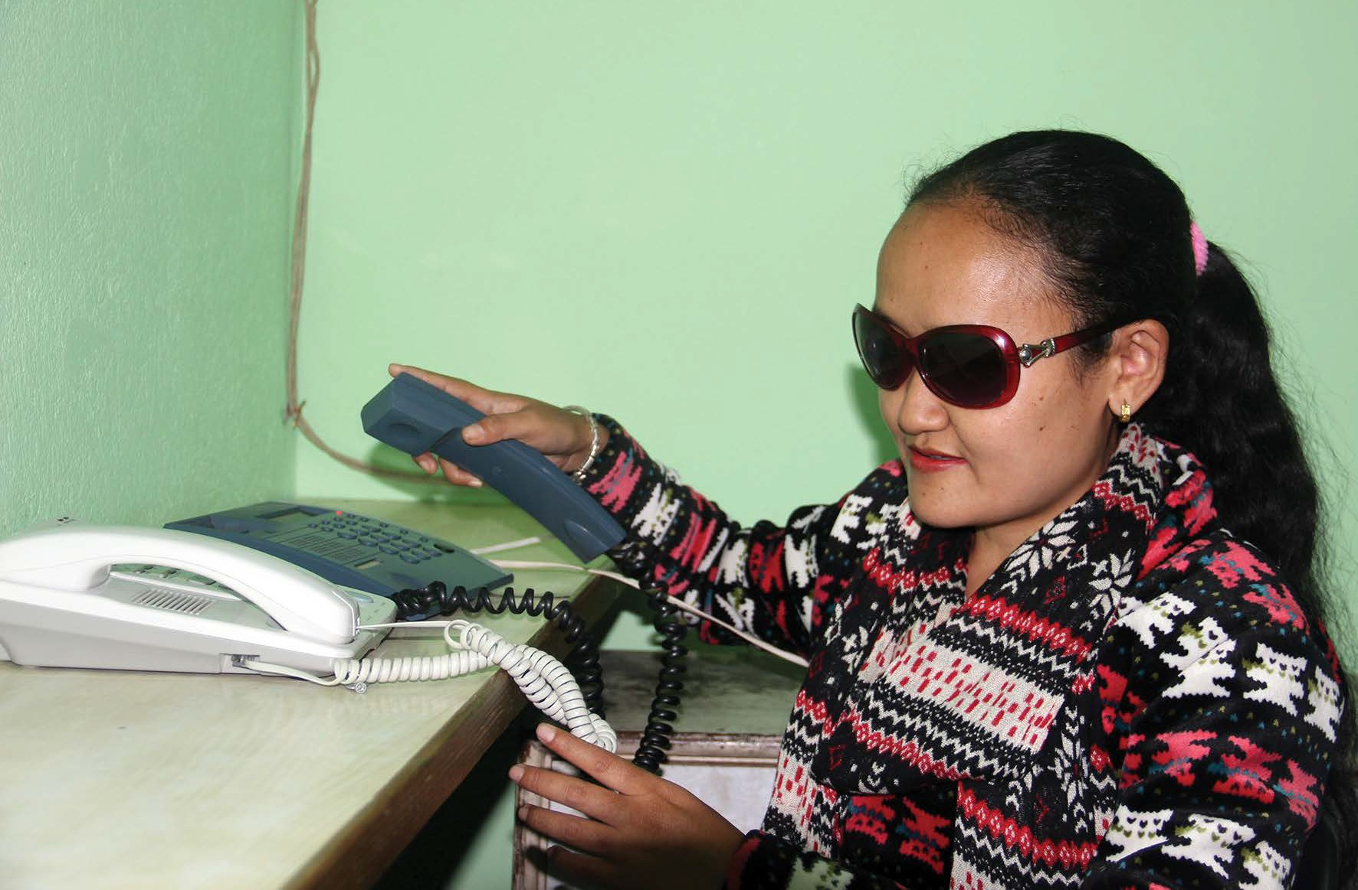

Introduction
his handbook is an outline that deals with the process and practices in relation to employment opportunities for persons with disabilities in Nepal.
T
The purpose of this handbook is to make the employers aware that persons with disabilities can be equally productive and skillful and contribute to the job market. This new approach for people with disability in employment sector will ensure that disability is not deterrent to get into a regular workforce.
National Federation of Disabled Nepal has realized that persons with disabilities are not fully believed to be capable human resources in the Nepalese job market. However, we have also seen that there are some employers who are proactive and encouraged to provide stable employment to persons with disabilities in a regular basis.
Nepalese private sector has already an experience of employing persons with hearing disabilities, persons with visual disabilities, persons with physical disabilities, persons with short stature and persons with intellectual disabilities in different jobs. Similarly, the NGO sector also has employed many persons with disabilities.
1

National Federation of the Disabled Nepal has a policy that prioritizes qualified persons with disabilities in recruitment of new staff in its different projects. In micro scale, more faces have been exploring jobs in non-profit organization and the government sector. In this context, we expect that the employers will be sensitized, inspired and encouraged regarding why and how to hire persons with disabilies through this handbook.
Furthermore, this handbook is an open resource that strives to provide a disability-friendly environment in which goal-oriented individuals with disabilities thrive as they can achieve demanding challenges. Employers’ commitment to serving customers and to providing quality products will be reflected through alternative workforce. Ultimately, this handbook will be a support tool for creating a work environment in which the interest of employers will be met and inclusion of persons with disabilities in job market will also be promoted.
HIRING PERSONS WITH DISABILITIES

2

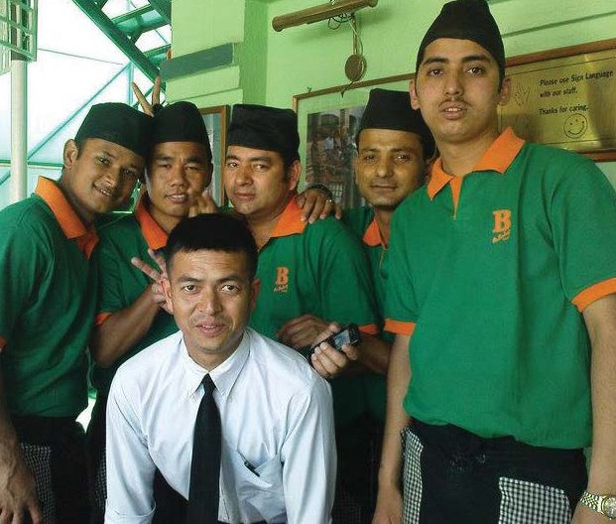

  - Why is it a good idea to hire persons with disabilities?
HIRING PERSONS WITH DISABILITIES
iring persons with disabilities is a good business. Real case studies around the world have indicated that these candidates are keenly dedicated, hardworking, and have a great appreciation for the
H
opportunity to work. With an aging workforce and projected shortfall in the overall workforce, a largely untapped resource pool, ready and able to work might be a huge benefit for your business.
Major employers have already demonstrated the benefits of employing persons with disabilities. The best way to begin to understand the opportunity and potential is to visit a company that has successfully hired employees with disabilities.
3

Major Companies that have hired persons with disabilities:

n The Bakery Café: Most of the waiters in this café are people with hearing disabilities.
n Deurali Janata Pharmaceuticals: Many employees in this company are people with hearing disabilities. They have gone a step forward and hired sign language interpreters for communication.
n Kathmandu Model Hospital: This hospital has hired people with visual impairment as their telephone operators.
n Tribhuwan International Airport: TIA has hired people with visual impairment and wheelchair users as their telephone operators and computer operators.

Some other examples are Laxmi Bank, Mega Bank, Baje Ko Sekuwa, Bhat Bhateni Super Market and Hotel Hardik. They have also hired persons with different kind of disabilities in different positions.
Similarly, a number of persons with disabilities have been selected in civil service through competition and are serving in good positions.
The I/NGOs sectors have employed many persons with disabilities.

Therefore, it is best to hire a person with disability as an employee in your business because:
HIRING PERSONS WITH DISABILITIES

    - It is a way to add value to your organization.
    - It is also a strategic way to strengthen your workforce and make it inclusive.
    - It will be seen as an informed business decision among your circle.
    - It will ensure that your products and services are better for a wide range of persons with different abilities.
    - It will give a strong message to the community that everyone can contribute if the environment is accessible.
    - It will create a good environment where persons with and without disabilities can learn from each other and ultimately reduce the discrimination and misconception about disability and disabled people.
    - And most of all, it is an achievable goal.
4

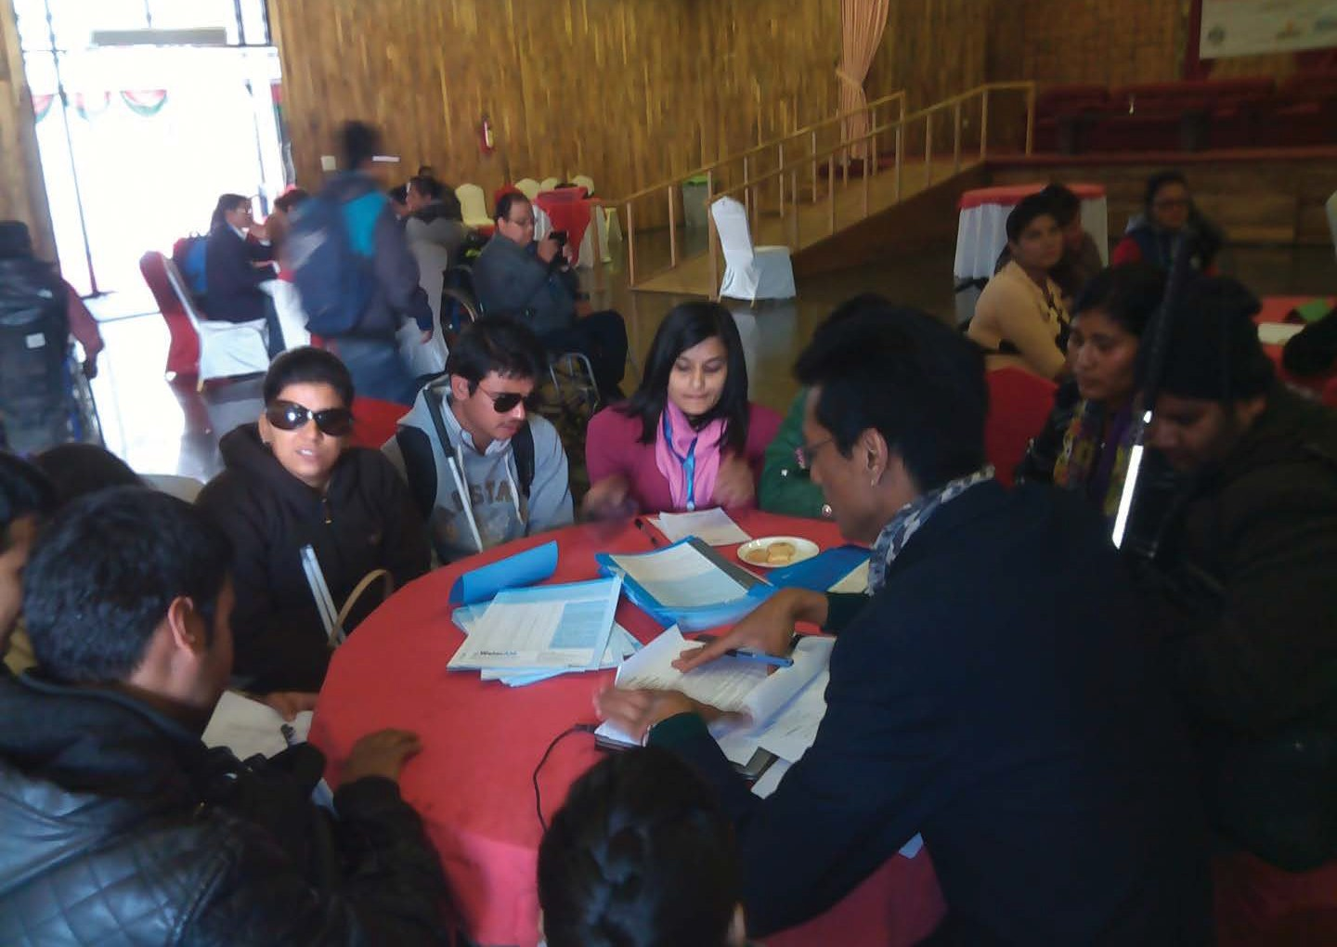

Business Case
If we look at the business case, there are 3 main reasons to employ persons with disabilities.

Return on Investment (RoI)
HIRING PERSONS WITH DISABILITIES
Businesses that employ persons with disabilities turn social issues into business opportunities. These opportunities translate into lower costs, higher revenues and may increase profits.
INCREASE REVENUES
  - Access new markets.
  - Improve productivity through innovative and effective ways of doing business.
REDUCE COSTS
  - Reduce hiring and training costs.
  - Increase retention.
  - Reduce costs associated with conflict and litigation.
ENHANCE SHAREHOLDER VALUE
  - Capitalize on opportunities to meet business goals.
5

Marketing
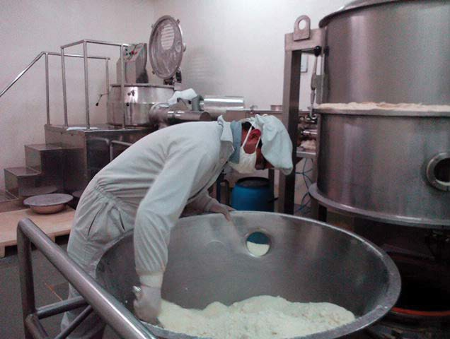
Customers with disabilities and their families, friends and associates represent a huge market segment. They, like other market segments, purchase products and services from companies that best meet their needs. Another benefit of employing persons with disabilities is an increase in your opportunity to gain a lasting customer base.

Innovation
HIRING PERSONS WITH DISABILITIES
Innovation is the key to your business success. Employees with disabilities bring unique experiences and understanding that transform a workplace and enhance products and services. By employing persons with disabilities, the company may get many ideas to develop new products and services which are accessible to all. This will definitely help the company run ahead of the competition and increase market share.
6

Studies have shown that employee with disability stays longer in a company as compared to those without disability. They want to give their best in the job and excel in that very job rather than shifting to new one. This will certainly benefit any company that hires persons with disabilities because their staff will stay longer and they will have low financial losses to be covered due to the undesired staff turnover.

Recognition by National Law
Section 8 (4) of the Disabled Protection and Welfare Act, 2039 of Nepal states that: A business which appoints more than 25 employees is liable to appoint persons with disabilities in a number not less than five percent of the total number of the employees to the appropriate works, to the extent available, on the basis of their capability, training, qualifications and experience. Such employee with disability shall get remunerations as equal to other employees.
HIRING PERSONS WITH DISABILITIES
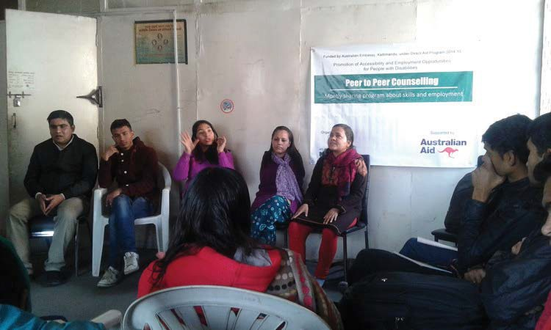
Their terms of service and career development opportunities shall also be the same as of the other employees.

7

Recognition by International Conventions
There are two main international legal instruments that regulate the employment rights of persons with disabilities.
- UN Convention on the Rights of Persons with Disabilities (2006) and its Optional Protocol are the most achieved international legal instruments on disability. Nepal ratified the UN Convention in 2008.

Reasonable accommodation means: “necessary and appropriate modification and adjustments
not imposing a disproportionate or undue burden, where needed in a particular case, to ensure to persons with disabilities the enjoyment or exercise on an equal basis with others of all human
rights and fundamental freedoms” (Article 2, CRPD).
Article 27 of the UNCRPD concerns the right to work of persons with disabilities, emphasizing the following:
- No discrimination on the basis of disability.
- Accessible job market and working environment.
- Promotion of employment in the private sector.
HIRING PERSONS WITH DISABILITIES
- Ensuring reasonable accommodation.
- ILO Convention No. 159 and Recommendation No. 168 also regulates rights of persons with disabilities. The convention promotes:
- Equal opportunity between disabled workers and workers generally.
- Equal treatment in respect of access to, retention of, and advancement in employment.

...a reality in which persons with disabilities are valued for their abilities and are seen as agents of productivity, innovation and competitiveness and as an integral part of the world of work is absolutely possible.

Guy Ryder
Director-General, International Labour Organization (ILO), October 2014
8

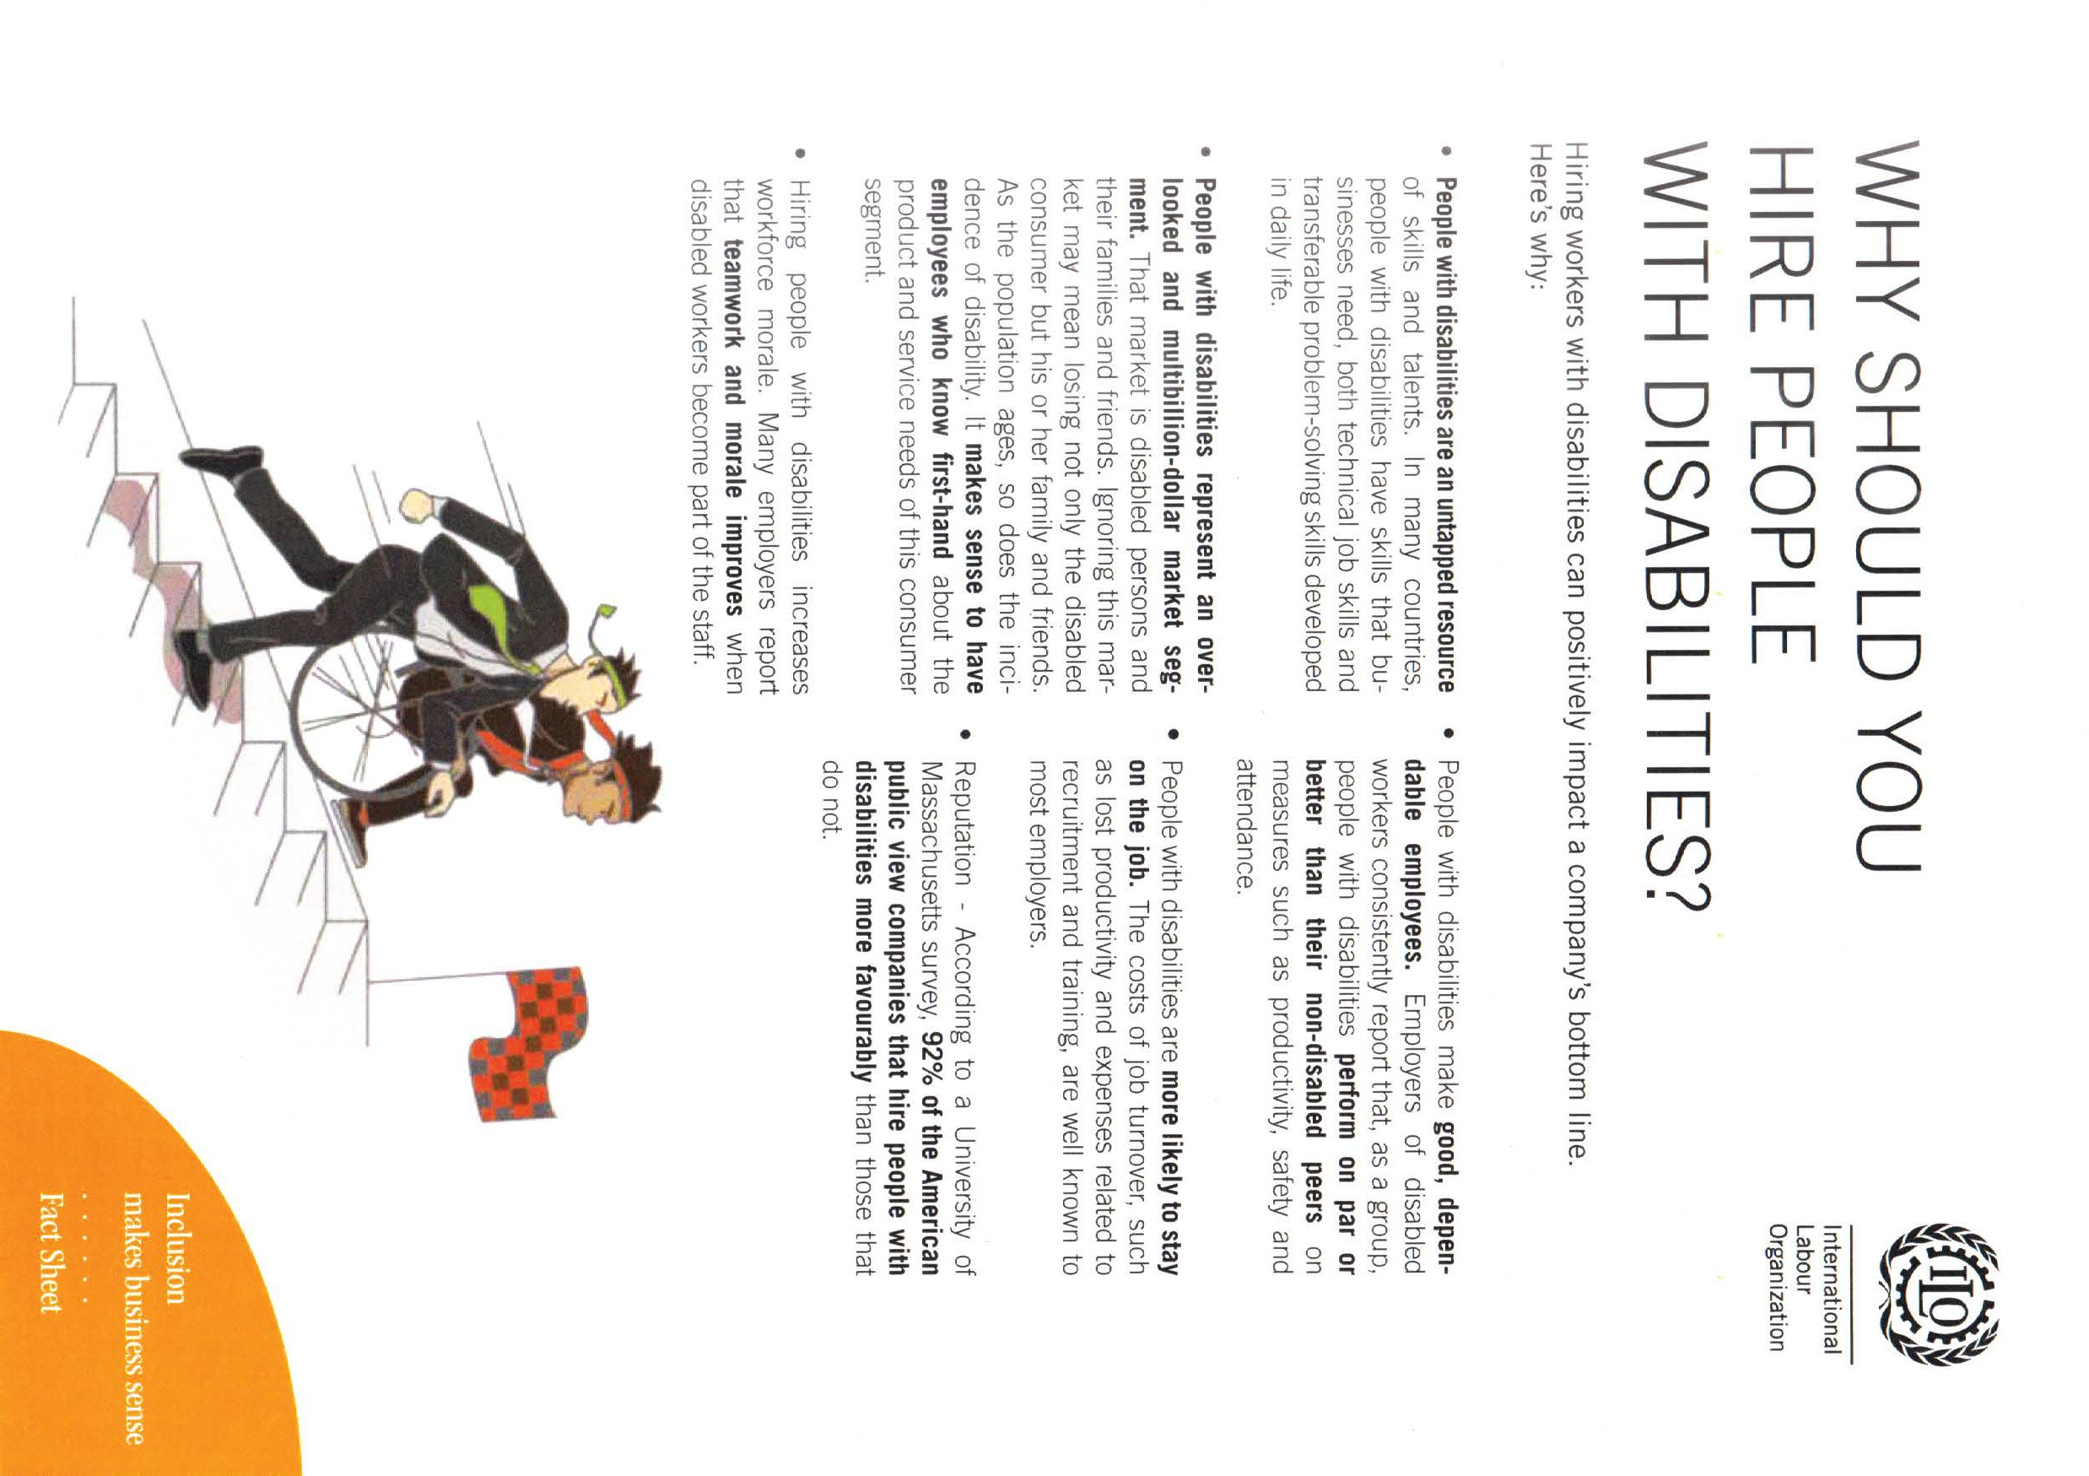

HIRING PERSONS WITH DISABILITIES
9

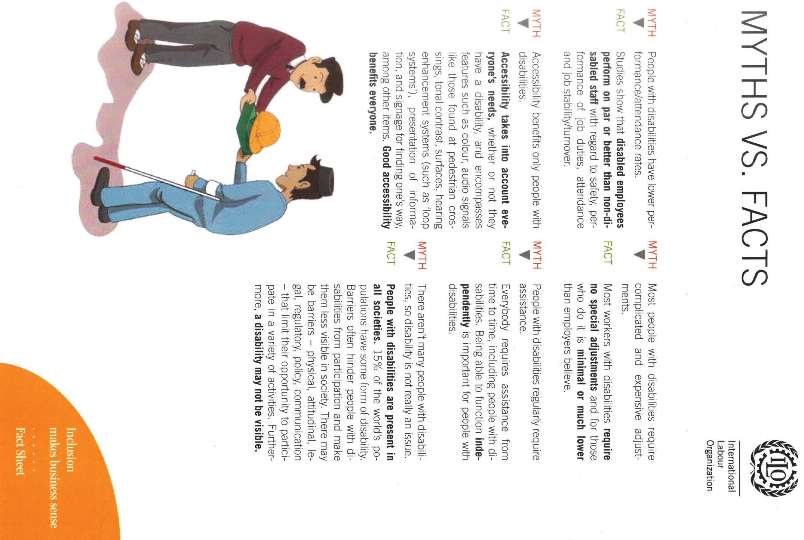
HIRING PERSONS WITH DISABILITIES
10

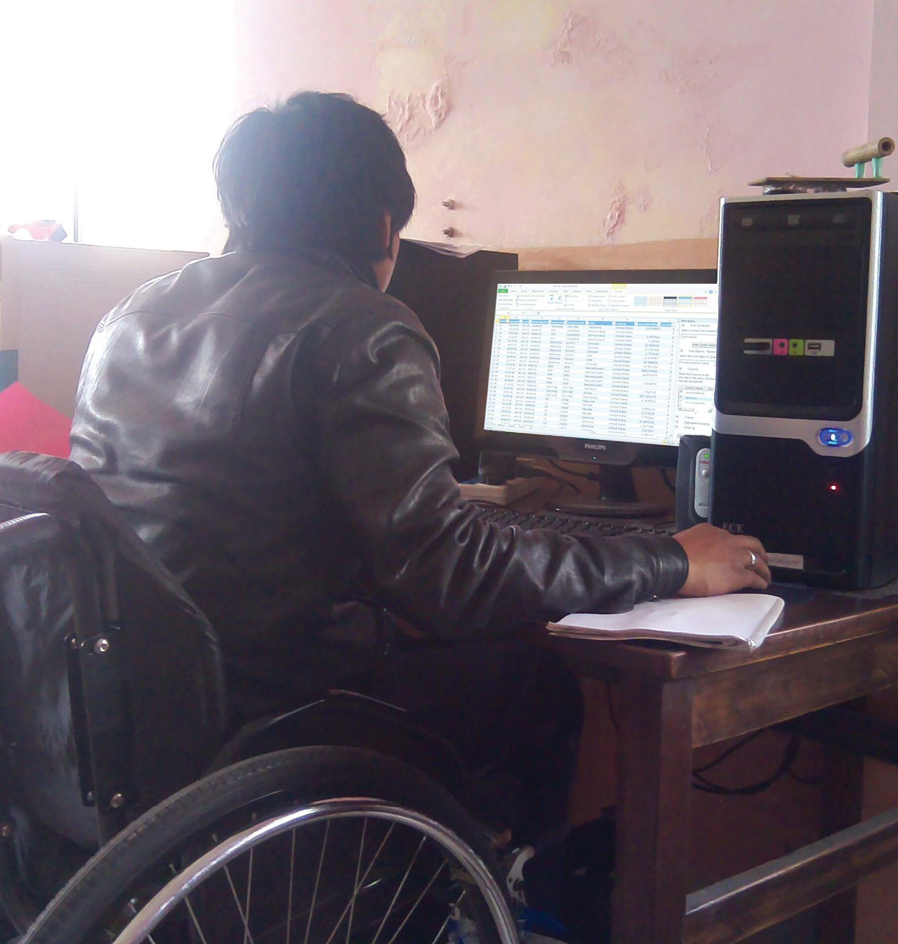

Cost of Exclusion
T
he study conducted by ILO in 2009 on “The Price of Exclusion: The Economic Consequences of excluding Persons with disabilities from the World of Work” suggests that the changes in the environment
may narrow the gap between the actual and the potential productivity level of a person at a given disability level.
The study applies the approach to a selection of ten low and middle- income developing countries. It concludes that economic losses related

11
HIRING PERSONS WITH DISABILITIES

to disability are large and measurable, falling into a band between 3 and 7 per cent of GDP.
In addition, this study distinguishes potential and actual productivity of persons with disabilities. This is useful to indicate that persons with disabilities are less productive not because of their physical condition
rather it is because they live and work in environments that are “disabling” them. In other way, we can say that, we are losing a good workforce
by creating different barriers which hinder their access in the job market. This gives us a message: it makes economic sense to create an environment that is supportive for persons with disabilities.
However, the biggest roadblock found while calculating the economic consequences of unequal opportunities among people with and without disabilities is the lack of reliable and comparable primary data.

A glimpse of cost of exclusion:
- Exclusion from labor market results in total loss of US$891 million/year in Bangladesh and those income losses among adult caregivers add an additional loss of US$234 million/year (estimate from world bank).
- High losses to GDP.
- Limits diversity in the workplace.
HIRING PERSONS WITH DISABILITIES
- Reduces labor pool.
- Innovative disadvantage-product and service development
- Discourages a large body of customers
- Competitive disadvantage
- Reduction of country health status due to economic disparity (OECD figures)
- Increases social unrest

Exclusion magnifies impact of the loss of labor market because of out migration-1500 people/day in Nepal

12

Hiring Persons with disabilities: The Process

“How will it affect my business?”
“Can I get the same level of performance as I am getting from others ?”
“Who else employs persons with disabilities?” “How could I provide a suitable job?“
“Will it be possible to find someone who fills the requirements?“ “How can I get an idea of the potential of the candidate?”
“But how will co-workers react?” “Won’t his/her personal problems interfere?”
“Can I discuss performance and behavior if necessary?” “And what if it goes wrong?”
HIRING PERSONS WITH DISABILITIES
“Can we do business?”

13

Be Motivated
You are not alone. There are hundreds of organizations all over the world that have been hiring persons with disabilities for a long time. Even in Nepal, there are some businesses, NGOs and INGOs that have successfully hired persons with disabilities as their employees.
Visiting these organizations locally and/or sharing the ideas among your network will give you a good start in the process of hiring persons with disabilities.
There are many organizations and experienced people working in disability or employment issues of persons with disabilities who you can consult with.
There are a number of persons with disabilities who are doing amazing work in the community.
Visit, talk and exchange ideas with them.


14
HIRING PERSONS WITH DISABILITIES

Make your Human Resource (HR) Policy disability friendly
Every business or company already has a HR Policy. It has comprised of a definite sets of roles, targets and rules for hiring your employees. Now is the time to make it disability friendly. Include a section on disability in the policy and highlight how you want to proceed ahead on hiring persons with disabilities as your employee.
The disability section of every company’s HR Policy should contain:
- A disability strategy on employment objective and the long-term perspective towards sustainable employment for employees with disabilities.

It is important to determine a strategy regarding employment of persons with disabilities, including the consideration on which disability issues should be covered and how it can be linked to existing policies. In this process, consultation with all stakeholders working in and with the factory is a must. These stakeholder will consist of Trade Unions, HR managers, General Managers, buyers and existing employees with disability, persons with disabilities themselves and the organizations representing them.

- An agenda on disability awareness raising training for all employees and their supervisors/managers.
It is very important to raise awareness about disability among all workers and their managers at your company. This will be crucial for inclusion of an employee with disability.

- A recruitment policy to hire persons with disabilities.
Targeting number of workers with disabilities to hire each year; establishing contact with disability related organizations and doing periodical job analysis are important parts of a recruitment policy.
HIRING PERSONS WITH DISABILITIES

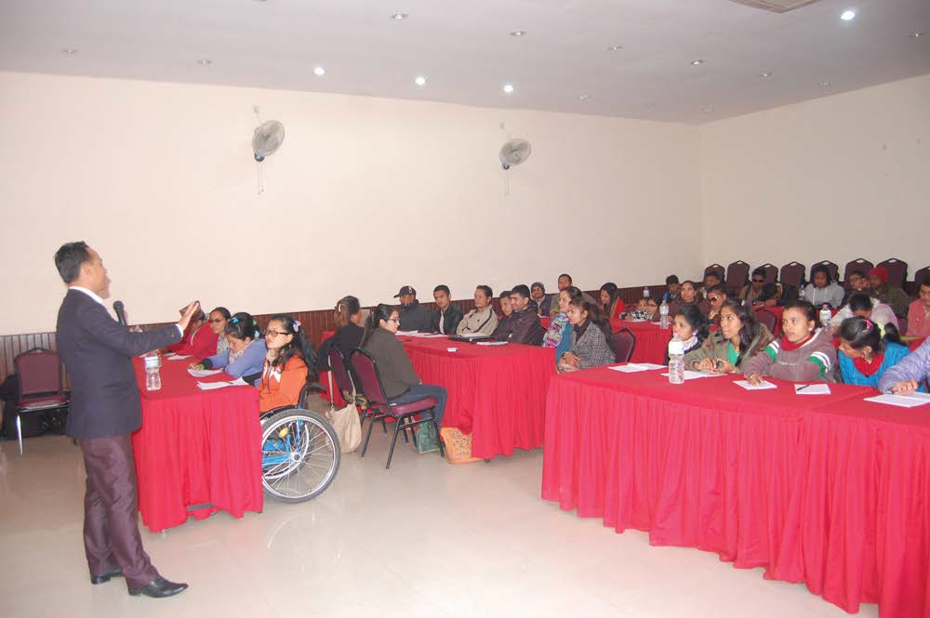
15

Do Job Analysis
In a company or business, it is important to conduct- a job analysis in order to assure effectiveness and productivity of all of its employees. It is more important in case of employees with disabilities. Job Analysis will give required information about the job to the employees and ensure him/her that s/he will perform the task in the best way. This process will also help the company in clarifying its needs and requirements for any vacant position.
Job analysis is a systematic process that involves 5 major elements. They are:
  - Purpose: What is the general nature of a particular job? Why is it important?
  - Tasks: What are the major tasks to be performed? How complex are they? How do they relate to other jobs in the section or department?
  - Environment: How is the working environment in which the tasks are performed?
  - Working conditions: What working conditions are applicable to this job?
  - Qualifications: What education, knowledge, skills and attributes are required for the performance of this job?
HIRING PERSONS WITH DISABILITIES
It is very crucial that the job analysis should be done precisely. Without precision in the process of task identification, it will be difficult to define answers to the questions like:

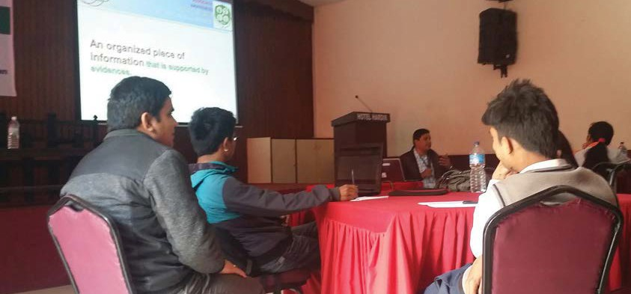
16

  - Which tasks might be eliminated or modified from the initial job description to potentially make it more suitable for a persons with disabilities?
  - What adaptations to the work environment, tools and equipment would make it more suitable for an employee with disability?
When conducting a job analysis, it is very important to always consider that a person with disability is able and has the skills to do the job.
The purpose of this job analysis is to not discriminate and eliminate persons with disabilities from performing certain tasks but to find ways to make the job suitable for them without losing the primary responsibility of the job.
Job analysis is an assessment that can be done for any applicant - with or without disability.
If the company has never hired persons with disabilities before, it is important to do the job analysis as seriously as possible. It is crucial to do everything possible to make the first recruitment a success.

Make your workplace accessible for persons with disabilities.
Since you are now committed in hiring persons with disabilities in your workplace, it is the right time to look around your office or business and find out what might be the challenges for a person in a wheelchair or
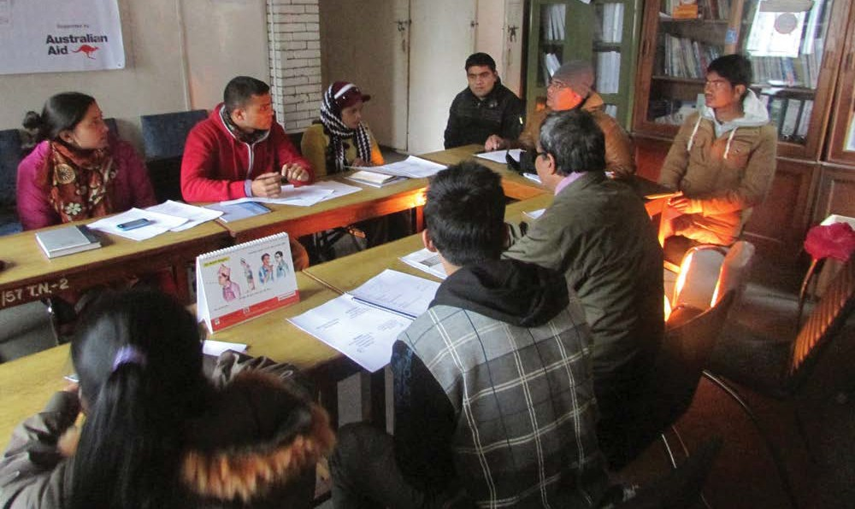

a person with visual impairment or a deaf person etc. to come to your place. Think about door’s width, stairs, toilets, height of working desk, any obstacles in the path, communication strategies, computer software etc.

17
HIRING PERSONS WITH DISABILITIES

Making workplace accessible is not as costly as people might think. A simple example might be a wheelchair ramp or Large Text Notice Board or a Free Computer Software for Visually Impaired people. You can find many Low Cost or No cost accessibility solutions.
(Some of these examples are discussed later in the book)

Promote your vacancies to persons with disabilities.
  - While advertising about job vacancies through any medium, include the diversity statement. A diversity statement is a short message that will tell the public that your company encourages applications for any vacancies from people from wide range of communities.
It can be as simple as- Persons with disabilities are encouraged to apply.
  - While participating in fairs, exhibitions and seminars etc., let people know that you want to hire persons with disabilities as your employees. Even if there are not any persons with disabilities
present in such events; your willingness to hire them will reach them eventually.
  - Employers can also surf through Hire me section of Mero Job.com at http://www.merojob.com/hire-me/fpwdsingle.php to view the profile of Candidates with Disabilities looking for jobs.
HIRING PERSONS WITH DISABILITIES

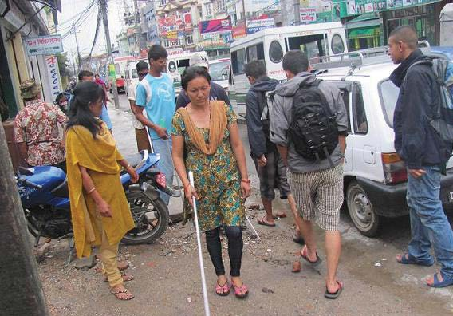 18
Photo Source: National Association of the Blind, Nepal

Connect with Disability Organizations
Disability organizations are main hub for persons with disabilities. They come to these organizations to know more about the opportunities available. So, having a connection with these organizations will be beneficial to your organization for searching potential employees.
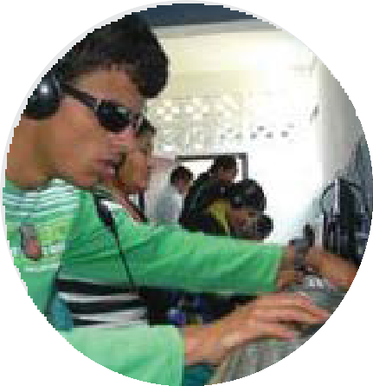Improving the living standard and promotion of the rights of persons with disabilities is the major foundation of
establishing disabled people’s organizations (DPOs) in the world. Persons with disabilities believe that uniting them
in DPOs result the best in advocating change regarding identifying needs, prioritizing and evaluating services from their own. In addition, creating an employment opportunity is also the step of including and equalizing persons with disabilities in the mainstream process.
There are several things DPOs might do for your business:
- Bridging the gap between persons with disabilities and potential employers.
- Recommend reasonable accommodation for persons with disabilities at the workplace and assist employer to ensure it.
- Provide job searching skills by organizing, seminar, fairs and conferences.
- Can technically assist to implement inclusion policy.
- Implement disability policy.
Sustainability comes from the long term partnership with DPOs in regard of deploying persons with disabilities. To have technical and financial partnership with DPOs will be fruitful in bringing persons with disabilities as new workforce. The DPOs diversely demonstrate their role by facilitating, suggesting and providing technical support/input to
manage new alternative workforce in the form of employing persons with disabilities in the potential institutions. The deployment of persons with disabilities with reasonable accommodation culminates the succession of organizational goal.

19
HIRING PERSONS WITH DISABILITIES

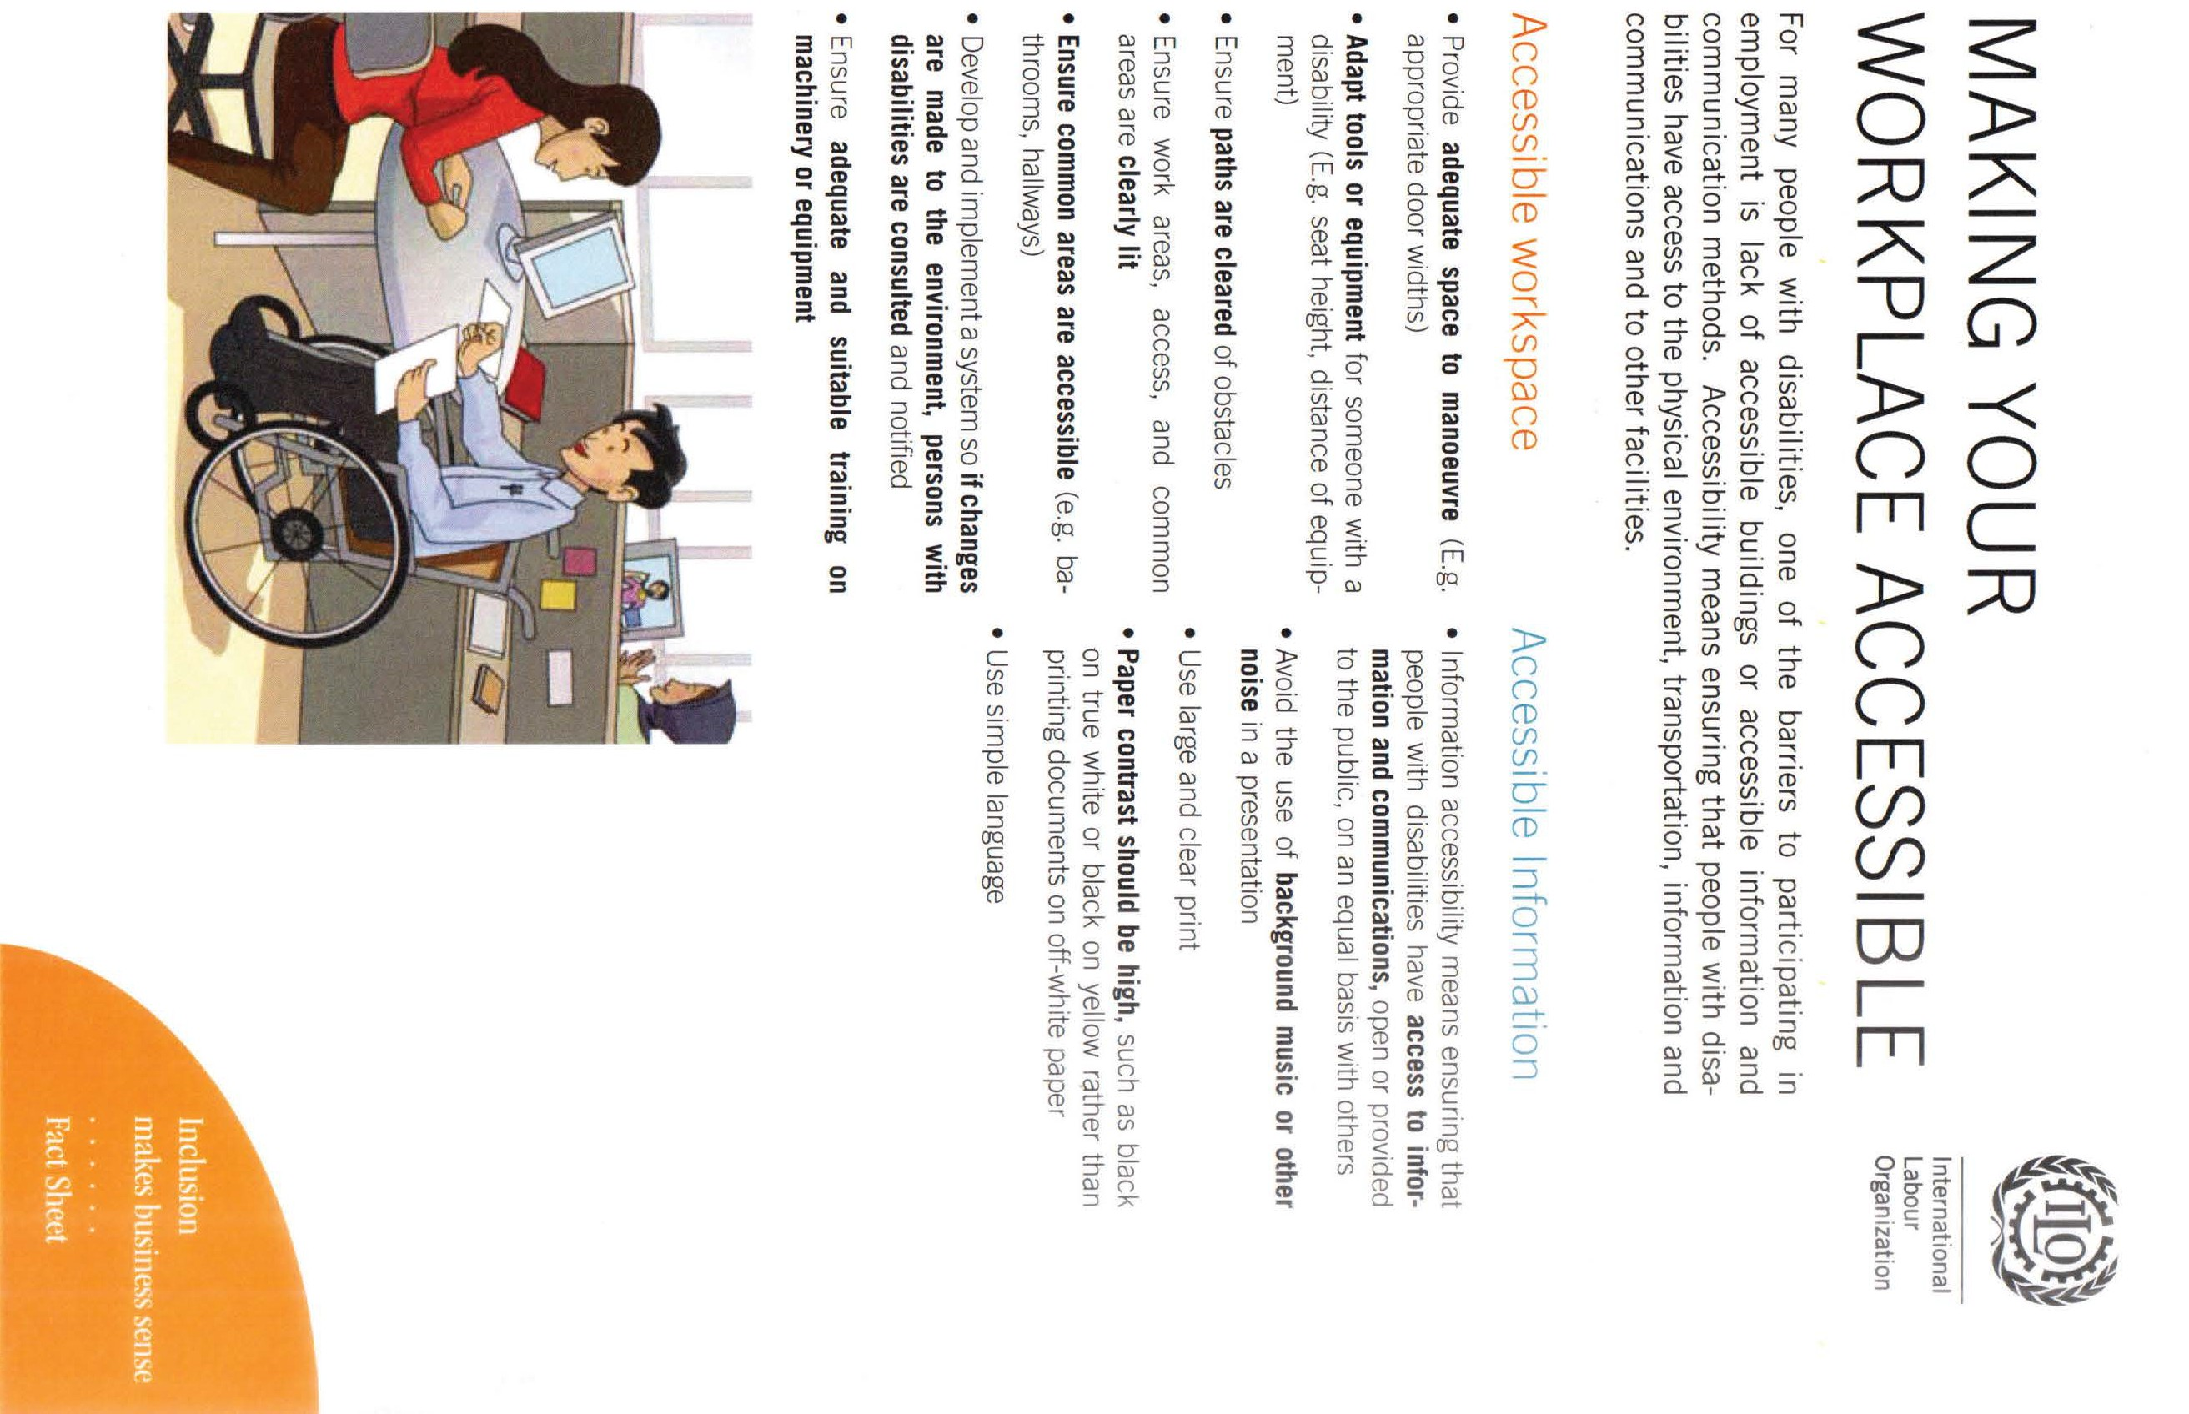
HIRING PERSONS WITH DISABILITIES
20



- Post Hiring: Managing Employees with Disabilities.
HIRING PERSONS WITH DISABILITIES

INTERACTING WITH PERSONS WITH DISABILITIES

There are three important points to remember when interacting with persons with disabilities:
Always ask a person with disability before you offer help. In some situations they might seem to have difficulty conducting tasks, yet
1
the person may be capable and prefers to do it without any assistance. If the person needs help wait for the person’s cue and ask if you are not

21

sure how to provide the help. Do not get offended if your assistance is declined.
Be sensitive about physical contact. Some persons with disabilities use tools or mobility aids like cane, crutches, wheelchair or walker,
2
special shoes, artificial limbs etc. Consider these aids as their personal space. Be careful as to not move or lean on their mobility aids.
Do not make assumptions about a person’s desire, needs, capacity or what is best for the person. If you’re not sure, ask questions about
3
what to do, what to say and what type of assistance you should offer and how to do it in order to avoid misunderstandings.
Language: Use friendly language and avoid all those words, sentences or terminologies which hurt or disrespect them.
4
Do not think that persons with disabilities are very special or extra- ordinary and what they are doing is very amazing. Just treat them as
5
normal people/staff so that they do not feel out of place?
Do not mention or point out his/her disability or physical condition frequently while presenting or introducing him/her. Talk about his/
6
her capacities and quality.

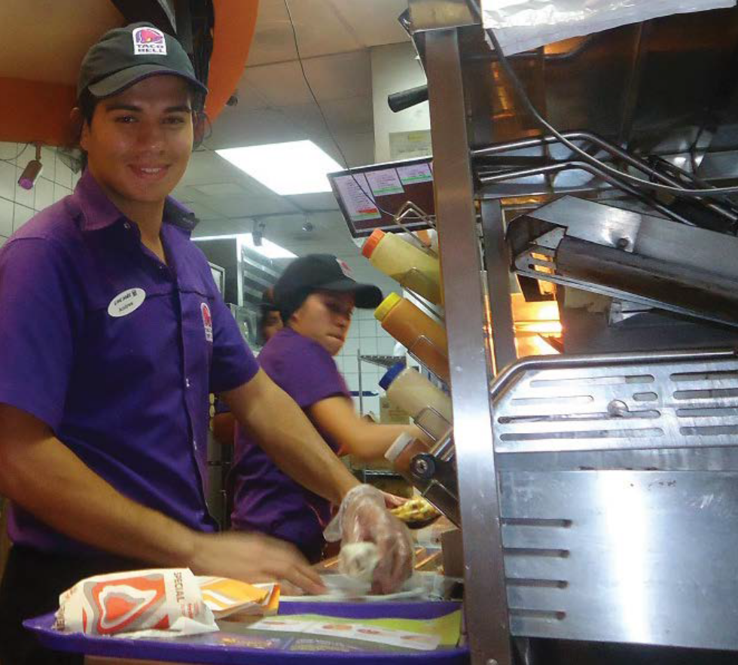Photo Source: Zero Project
HIRING PERSONS WITH DISABILITIES

22

INTEGRATING EMPLOYEES WITH DISABILITIES IN THE WORKING ENVIRONMENT
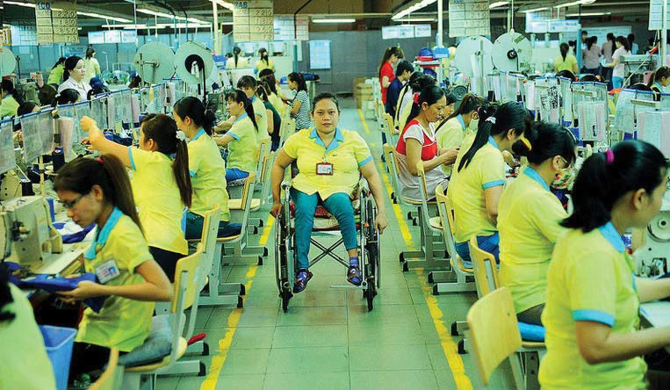
Good communication and pleasant staff relationship are necessary for improved productivity and a good
work environment. It should be made sure that persons with disabilities
are well integrated in their new working environment. For this, raising awareness amongst managers and workers prior to recruitment of persons with disabilities will be useful.
This sections provides some advice regarding smooth integration of disabled workers in the company staff.
Get acquainted about the disability
etiquette and makes sure everybody in the company is aware of it.

Take time to introduce workers with disabilities to all staffs. This will make everyone familiar to the worker with disability hence surprised
1
reactions from others members will be avoided.
Give workers with disabilities time to accommodate with the working space. Make sure that their work space is appropriate for effective
2
and productive work.
Make sure that, any kind of discrimination either from supervisors or subordinates towards workers with disabilities is avoided. If any
3
case of discrimination is reported, take appropriate measures to stop such behaviors immediately.
Some disabilities may require special attention. Persons with hearing impairment may need an interpreter. Learning basic sign language
4
will ease the adjustment of process. (Always remember that if you take the first step towards persons with disabilities, they will be grateful and in many case, it will be a rewarding experience.)
Provide real tasks that lead to real work achievements. A charity- based recruitment is not what any worker would appreciate. A
5
motivated worker, in this case, someone with disability is looking for jobs as anyone else, based on their skills and motivation for the job. If the recruitment is based on charity, it might be a disappointment for both

23
HIRING PERSONS WITH DISABILITIES

the employer and the employee. However, affirmative action during the recruitment process of persons with disabilities is still not to be forgotten.

ADAPTING THE WORKPLACE

Many times it is thought that making the workplace suitable for persons with disabilities requires a big financial investment. However, such accommodations do not necessarily require high expenses.
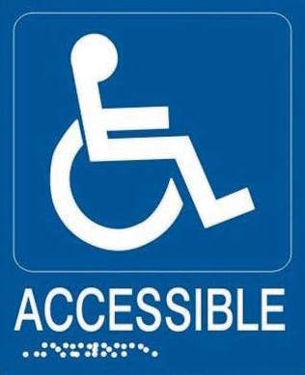Accommodating to some types of disabilities does not always mean physical changes but perhaps changes in working hours or in the way information is communicated. Persons with disabilities are experts in
l Physical accommodations:
- Keep the workplace clean and tidy.
- Make doors and corridors free from any obstacles.
- Make signs easy to read.
- Ensure that washrooms facilities are accessible for persons with disabilities.
- Build ramps or handrails where necessary.
- Put information in Braille or audio format where necessary

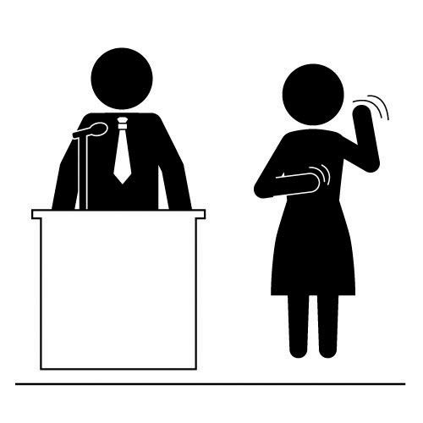 24

l Non-physical accommodations:
- Arrange flexible working hours.
- Use of large print in providing directions and/or notices/ information.
- The use of sign language in order to communicate or “work from home” opportunities.
- Provide special software in the computer when necessary.
HIRING PERSONS WITH DISABILITIES

This will enable a person with disability to perform his/her tasks easily
Always remember that these simple adaptations will benefit not only the person with disability, but all the employees and customers who come to buy products or services. Moreover, it will enhance the company’s image and as a result improve worker’s satisfaction and performance.


l Specifics to consider for workers with hearing impairments
- Make sure the room is well-lit.
- Get her/his attention before starting a conversation.
- Speak slowly and clearly.
- Take turns talking.
- Be clear that if an interpreter is available, she/he will only be repeating what you say without adding opinion.
- Be prepared to offer written communication.

l Specifics to consider for workers who have physical impairments.
- Allow enough space for a wheelchair or any assistive devices he/she is using.
- Provide height adjustable desk or table for a person who cannot work comfortably at an existing
sitting arrangement
- Provide accessible filing system for a person who cannot reach upper and lower file drawers in a vertical file cabinet.
- Place office supplies and frequently used materials on most accessible shelves or
drawers for a person who cannot reach upper and lower shelves and drawers.

25
HIRING PERSONS WITH DISABILITIES

- Provide page turners and book holders for a person who cannot manipulate paper.
- Place office machines, such as copiers and faxes, accessibly so a person using a wheelchair or crutches can reach them from a seated position.
- Make sure of an accessible route of travel from the parking space into the office building.
- Make sure that restrooms, lunchrooms, canteens, break rooms, etc. are easily accessible.
- Consider giving the option of working from home if the person cannot get to the work-site.
- When talking to a person using wheelchair for more than a few minutes use a chair whenever possible. This can facilitate conversation.

 26

l Specifics to consider for workers who are visually impaired
- Check that the working space is clear of things that could block her/ his moving space.
- Don’t move anything without asking first.
- Provide documents in the person’s preferred format.
- Provide a screen reader or other tools to accommodate her/him on work.
- When explaining a location, use clock-based directions.
Examples: “the pen is on the table at your 2 o’clock., please turn left or right, now you have to walk three steps down etc. “
- Give proper orientation of the working space/room, table, chair, filing cabinet, computers, other equipment and materials.
HIRING PERSONS WITH DISABILITIES

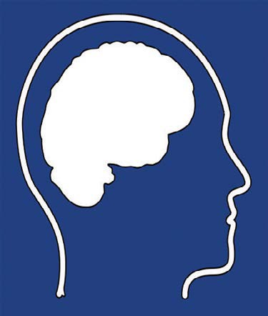
what they need and will be keen to help adapting the workplace properly.
Here are some examples:
l Specifics to consider for workers who
have learning disability
- Provide continuous support and acknowledgement for her/his work.
- Provide reasonable adjustments when necessary.
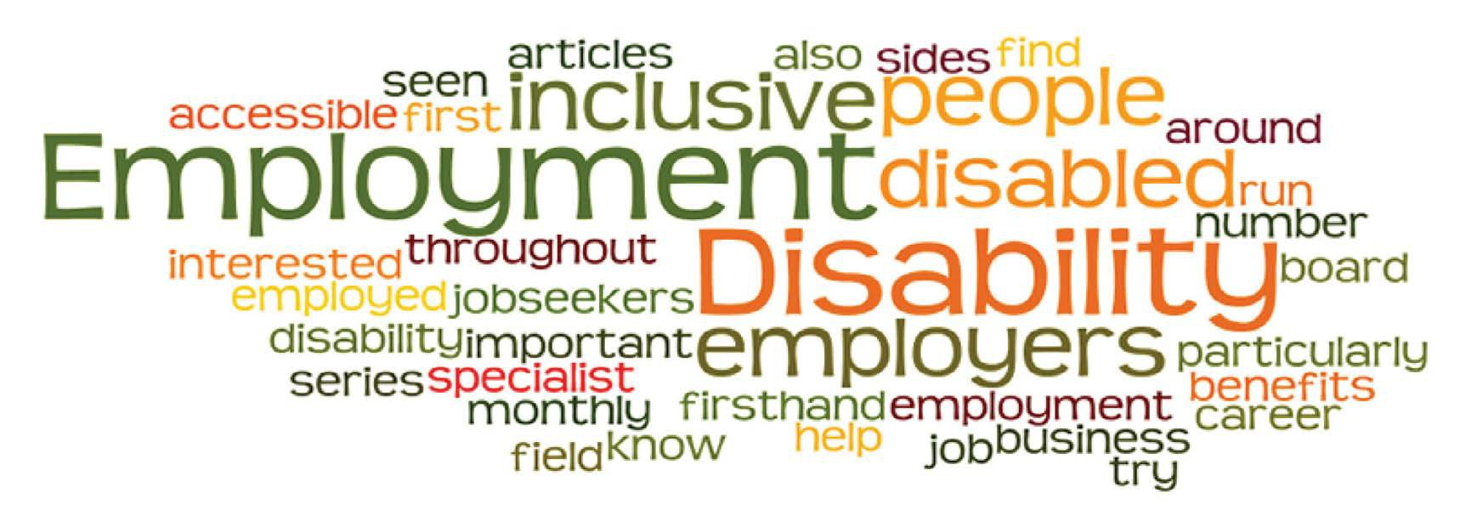

RAISE AWARENESS AMONG STAFF MEMBERS
Educating staff members on disabilities is an important step towards a more understanding, diverse and motivating working environment. And promoting non-discrimination at the workplace betters the employment of persons with disabilities. This will not only benefit the company but the whole society by transforming people’s mindsets and removing stigma and discriminatory behavior.

Provide Disability Awareness Training to All Staffs
Conducting trainings for all the employees including managers is necessary. Presentations, video testimonies from persons with disabilities and practical exercises are good ways to raise awareness. Inviting staff members to try getting around in a wheelchair or wearing glasses that hinders visual sense are simple exercises that helps to show what persons with disabilities live with every day. Collaborating with DPOs on disability awareness trainings is recommended for better outcomes on the training.

27
HIRING PERSONS WITH DISABILITIES

28

Disability Sensitivity Training
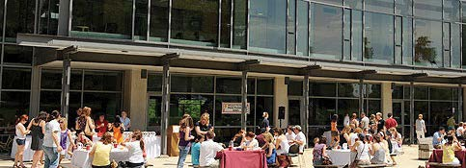
Orientation sessions for new staff and other trainings for employees should include a disability sensitivity training. This training can serve as a tool to introduce persons with disabilities to non-disabled people.
This also purports creating awareness and acceptance of persons with disabilities. This training is adaptable to any environment and materials can be adjusted based on the participants.
In relation to working environment, disability sensitivity training is generally provided for:
HIRING PERSONS WITH DISABILITIES

Companies or factories that previously have not recruited persons with disabilities.
Strategies:
- Introduce national/ international legislation and regulations on disability issues.
- Provide testimonials from companies or factories that have committed in obliging with the national legislation and regulations.

Companies or factories that have recruited persons with disabilities
Strategies:
- Provide specific guidelines on interacting with persons with disabilities in the work place. This can help minimize gaps in information
about issues related to disability, and most importantly, eliminate discrimination.
- Provide opportunities for workers with disabilities to tell their stories and express their opinions in order to improve the quality of the working environment, especially for persons with disabilities.

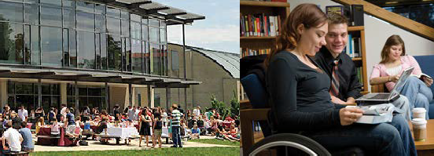
    - Provide Ongoing Information on Disability
Information on disability includes national and international disability legislations. This information can be provided regularly on the company’s intranet site, newsletters, and other media channels. A routine dissemination of information on disability is vital to raise important issues within the working environment.

Establish a Disability Support Network
All employees need to fully participate in providing services and assistance for workers with disabilities to contribute to successfully creating a non-discriminatory environment within the company or factory.

ON-THE-JOB TRAINING
Trainings relating to the job’s position need to be conducted for all employees regardless of their skills and disabilities. During the training period, workers with disabilities as well as non-disabled workers might encounter challenges in completing the tasks. However, shortcomings in learning process during the training period should not be seen
as someone’s incapability. The goal here is to prepare the workers in conducting their tasks so that they could contribute effectively and efficiently to the company or factory’s productivity.
Other training methods might be used or invented to fit the workers’ particular needs. For a successful training of workers with disabilities, it is suggested that the company/factory contacts a DPO that can help with training the workers.

29
HIRING PERSONS WITH DISABILITIES

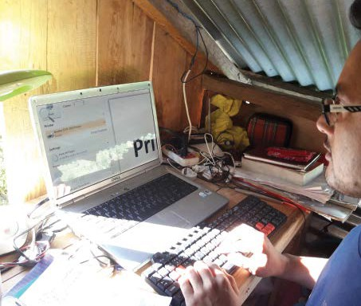

DISABILITIES WITH
PERSONS HIRING
30

Frequently Asked Questions

How do visually impaired people work using computer?

Visually impaired people use a screen read- ing software while using the computer. This software reads aloud the things displayed on their screen. People with low vision use a software called Magnifier which magni- fies their computer display. By using these softwares, a visually impaired person (both blind and low vision) can use computer as their sighted peer. They can use word, excel, PowerPoint to email and internet.

Both of these softwares are pre-installed in
every copy of Windows and Mac operating system. So there isn’t any cost burden on employers to provide these softwares to employee with visual impairment.

I want to hire persons with disabilities. But my office is not disability friendly. What do I do?
There is a wide spectrum of disability category and not every employee with disability will require a physically accessible workplace. If a person with one kind disability find certain work challenging to do, a person with another kind of disability might do it easily by using thier own accomoda- tion measures.

How do people with hearing impairment actually work without being able to communicate?
Persons with hearing impairment can’t speak or hear. However, this doesn’t mean that they can’t communicate. They use sign language to communi- cate with other. They can also communicate by writing in paper, texting in mobile, using online communication systems like email, chat etc.

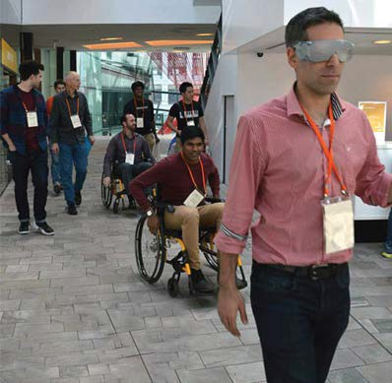
Photo Credit: Enable Development

Miscellaneous:

Facilitating the training process:
Employees need series of trainings to upgrade their knowledge. Companies invest a large amount to train their employees. Training a person with disability as an employee needs simplified techniques by which the whole training becomes more effective. It will also facilitate the resource person to deliver the contents of the training more effectively
to every participant. The trainer has to adapt new teaching methods due to which the learning from training becomes more effective with more takeaways. This technique enhances the presentation skills of the trainer and also reduces cost by providing opportunities to the in-house trainers.

31
HIRING PERSONS WITH DISABILITIES

Accessibility as prevention:
Existing employees have to work continuously in front of computer and may have already started to develop problems in their body. For example: Weakness of the eyes. An employee with low vision uses headphones to listen the audio and in built magnifier software to read texts of the screen. This facility can also be beneficial for employees who use spectacles,
to prevent further damage of the eyes while working. This help reduce headache and stress as well. The disability friendly environment thus, can be helpful in preventing unnecessary accidents.

Managing Employees during crisis:
During the time of natural and human-made disasters such as earthquakes and fire, accessible infrastructure are helpful for all employees while evacuating the building and ensuring safety measures. During a disaster, employees may acquire disability. The Organization needs to manage such employees with disabilities who have skills and knowledge and want to continue their work. There may be an existing provision of life insurance coverage and the employee may be reimbursed with the insured amount. However, that reimbursement may only be
a temporary way to appreciate employee’s contributions towards the company. Making the workplace accessible will be a sustainable solution.
HIRING PERSONS WITH DISABILITIES

Breaking the Barrier during Recruitment Process:
In many companies, employees have to go through a medical examination. They need a certificate from a Medical Professional

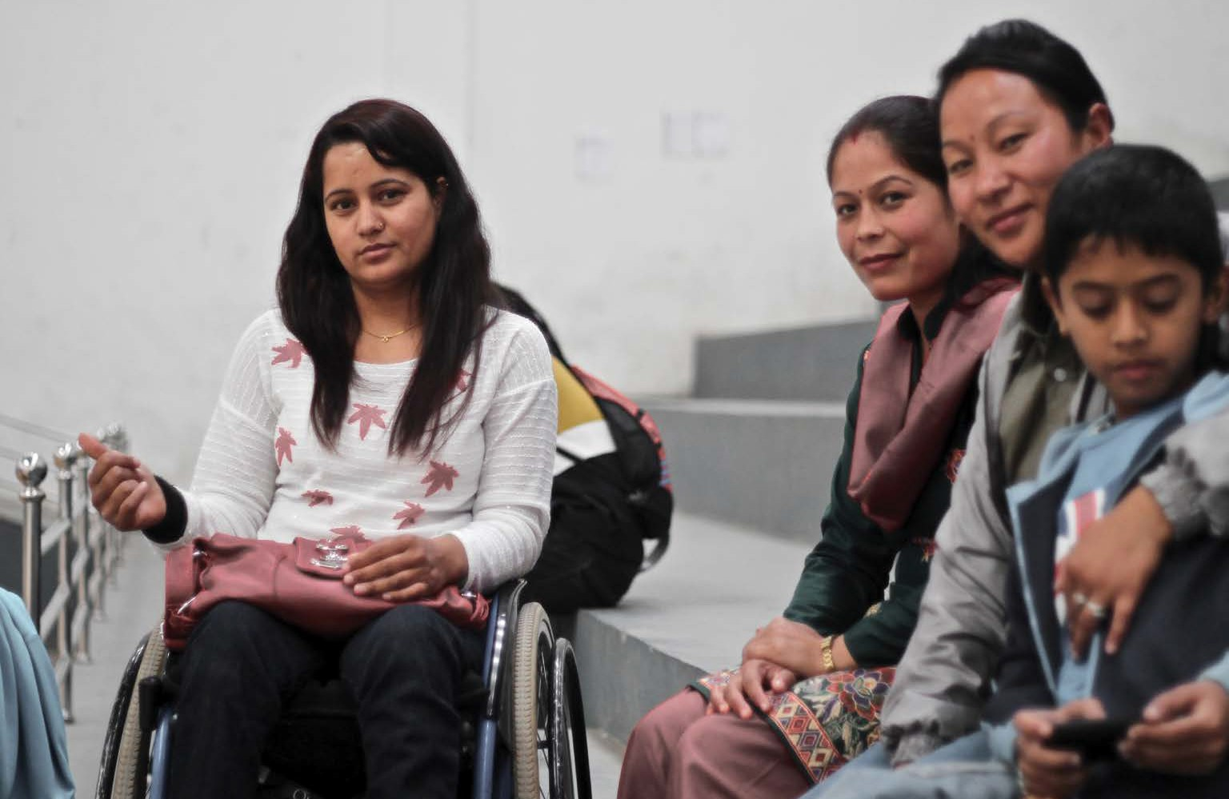 32
Photo Source: Baltic Review, Bibbi Abruzzini

certifying that he/she is physically and mentally fit for the job. Due to any kind of disability (despite fit and able for the job), the employee is rejected during the hiring process. The employer can make the
recruitment policy disability friendly which helps to hire a person with required skills despite of his/her disability.
Making accessible environment supports the person with disability to do the job. This perspective helps the employers to seek possibilities even during uncertainties and challenges faced in business.

Sharing Success stories:
An employer who has hired a person with disability can share the story of success during various events related to human resources functions.
Presentations an videos of successful placements of persons with disabilities to inspire many other employers to do the same. Talking about these issues will create a positive impact in market.

Charity or Recognition:
Often employers confuse hiring persons with disabilities to charity over tapping talent. This confusion is created due to the perspective that often persons with disabilities visit companies asking for funds as charity. Employers need to be informed that there are so many persons with disabilities who are skilled and talented, capable of doing job. They need a job to be financially independent and live a respectful life.
HIRING PERSONS WITH DISABILITIES
It is known that people without disabilities who are economically poor also visit different places asking for charities.

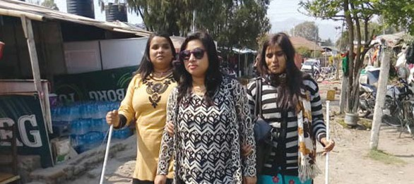
33

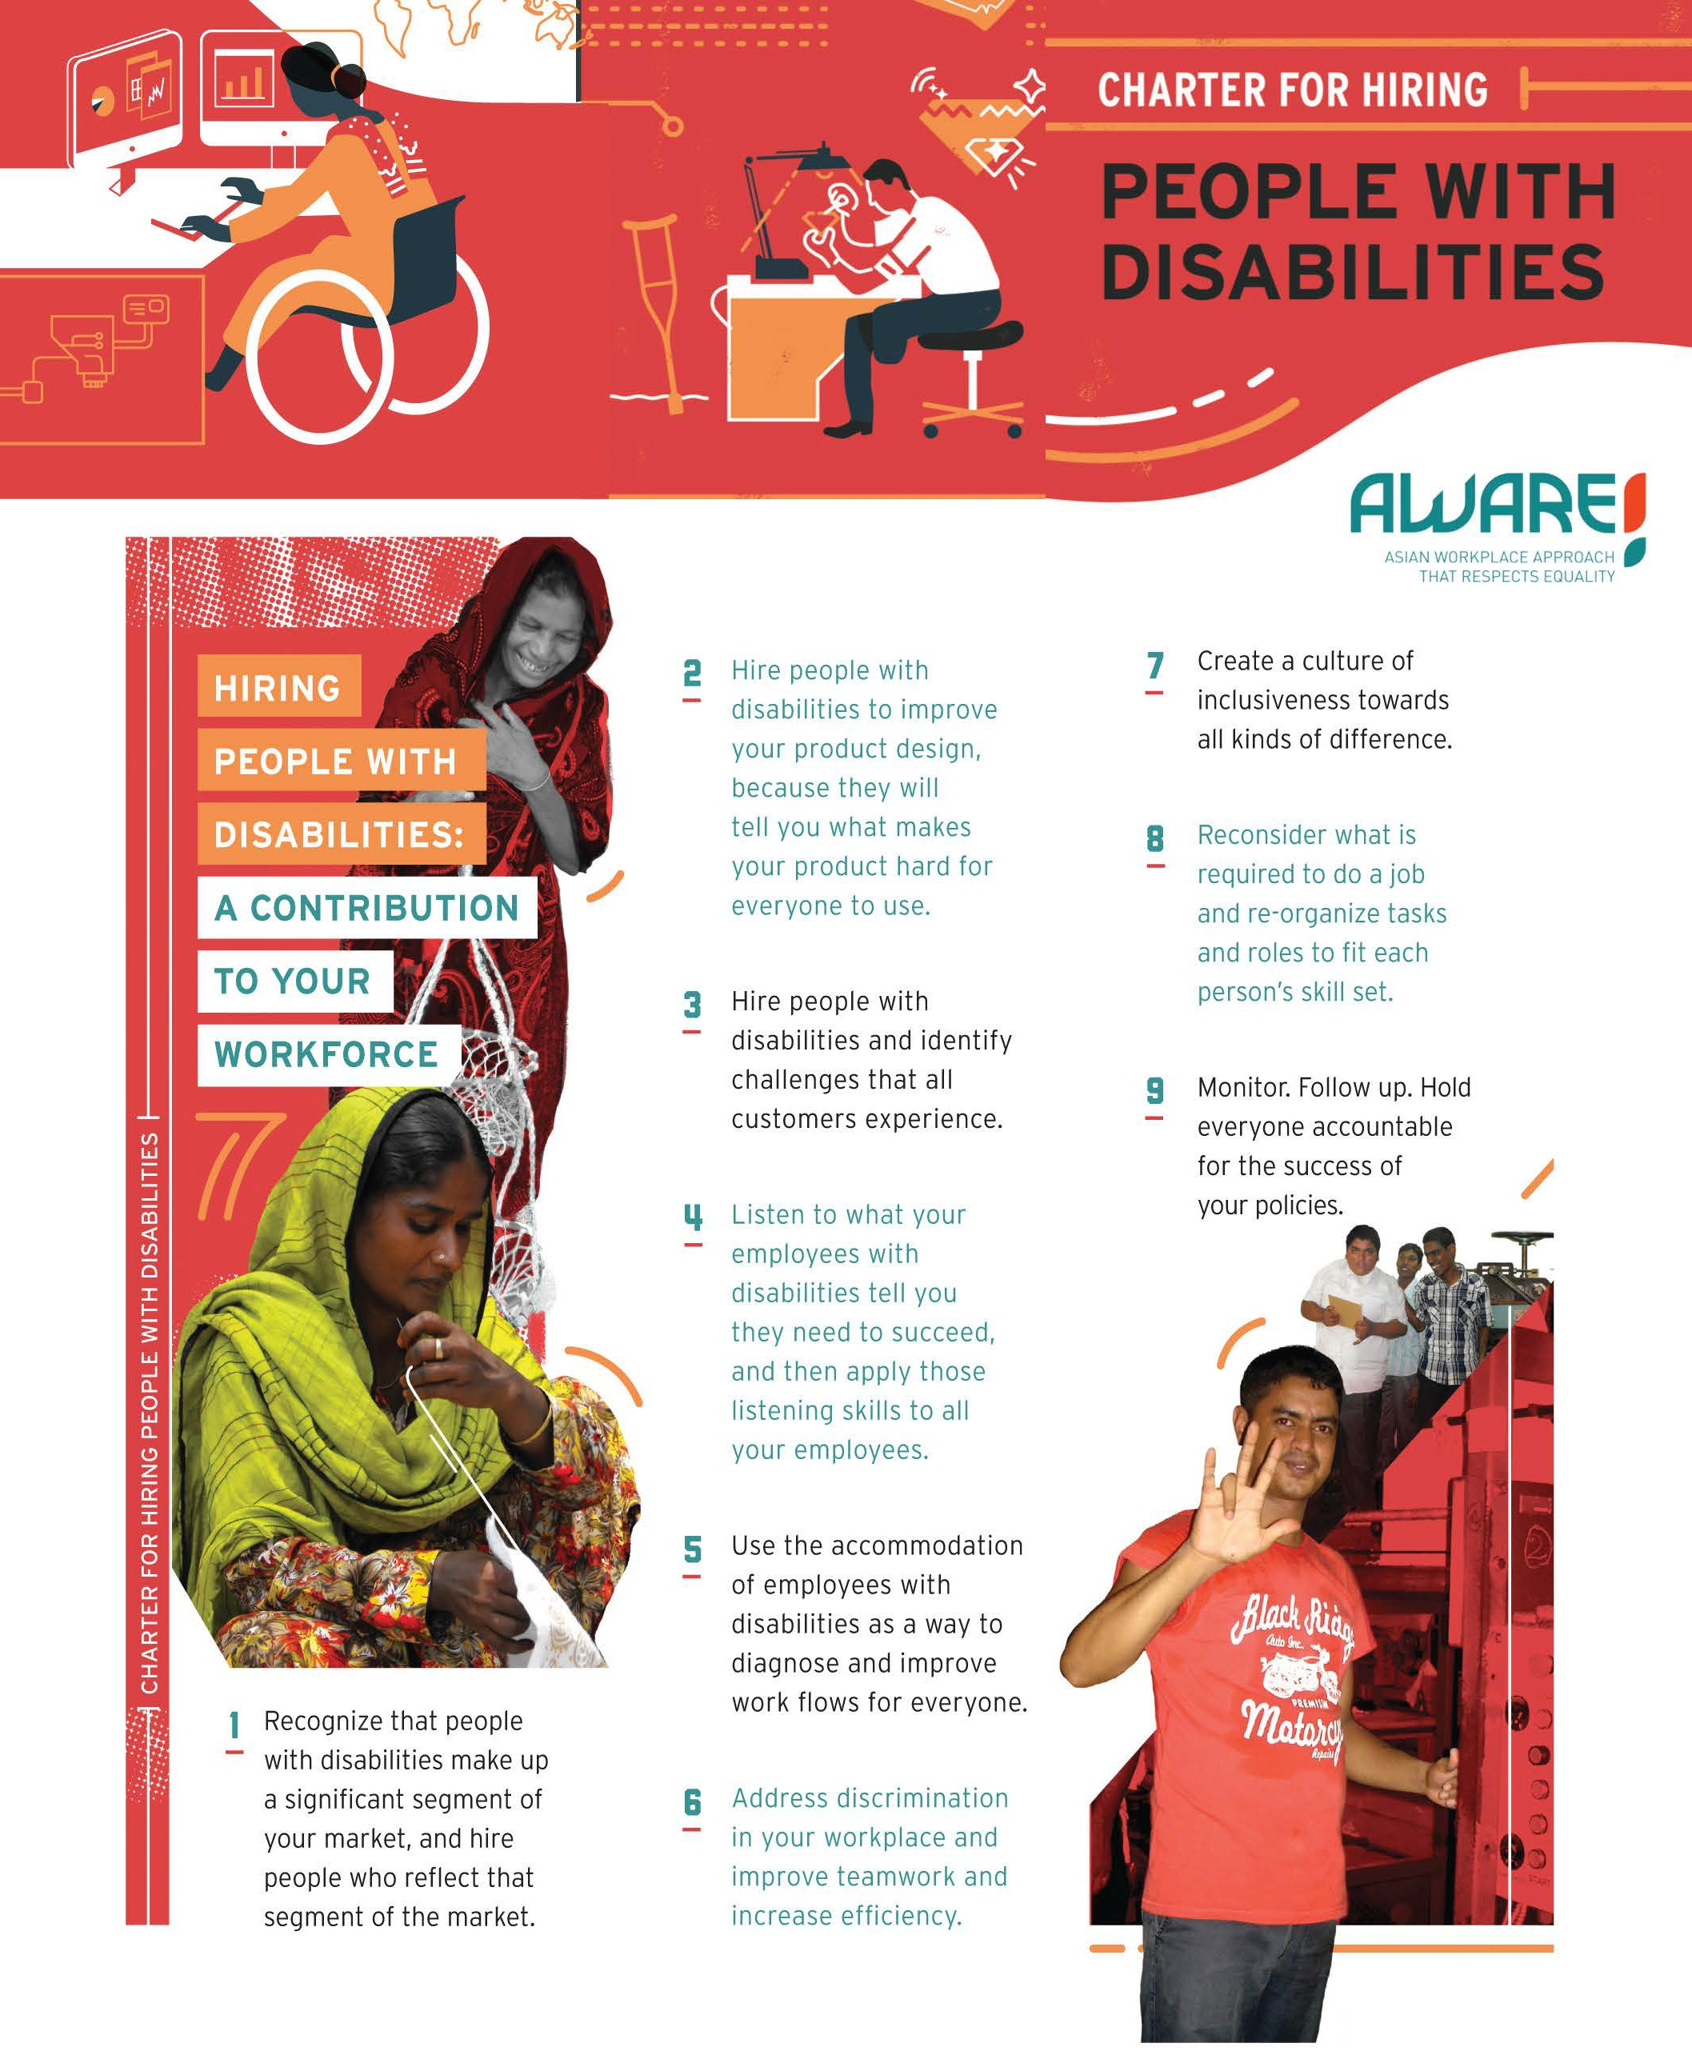

DISABILITIES WITH
PERSONS HIRING
34
This charter is prepared by Disability Rights Promotion International. Read more at: http://drpi.research.yorku.ca

Photo Credit: Handicap International, USA
HIRING PERSONS WITH DISABILITIES

Understanding Disability
T
he term ‘Disability’ is an umbrella term that covers four major impairments. They are Physical, Visual, Hearing and Intellectual impairment. Disabilities are frequently misunderstood as inability,
leading to negative stereotypes, discrimination and unintentional barriers in our communities and workplaces.

35

Disability means:
According to the definition provided by UNCRPD- “Persons with disabilities include those who have long-term physical, mental, intellectual or sensory impairments which in interaction with various barriers may hinder their full and effective participation in society on an equal basis with others.”

36
HIRING PERSONS WITH DISABILITIES

6.1 SPECIFIC DISABILITIES
According to the nature of the problem and difficulty in the parts of the body and in the physical system, disability has been classified into the following seven categories.

Physical Disability:
The problem in the operation, use and movement of physical parts due to physical deformities or problems in the operation of nerves, muscles, joints and bones of a person’s body is physical impairment.
For example: polio, cerebral palsy, absence of a body part, effect of leprosy, muscular dystrophy, problem with joints and spinal cord, club feet, rickets, weakness produced due to problem related to bones etc. are physical disability. People of short height also fall into this category.

Disability related to vision:
Disability related to vision is an impairment in which a person has no knowledge about an object’s figure, shape, form and color due to different problems with vision. This is of two types.

Blind:
A person who cannot see objects the size of fingers at a distance of 10 feet despite treatment (medicine, surgery and use of glasses), or cannot read any letters of the Snellen chart (3/60), is blind.

Low Vision:
If a person cannot distinguish objects the size of fingers at a distance of 20 feet despite treatments (medicine, surgery and use of glasses), or
cannot read the letters starting the fourth line and below of the Snellen chart, then that person has low vision.

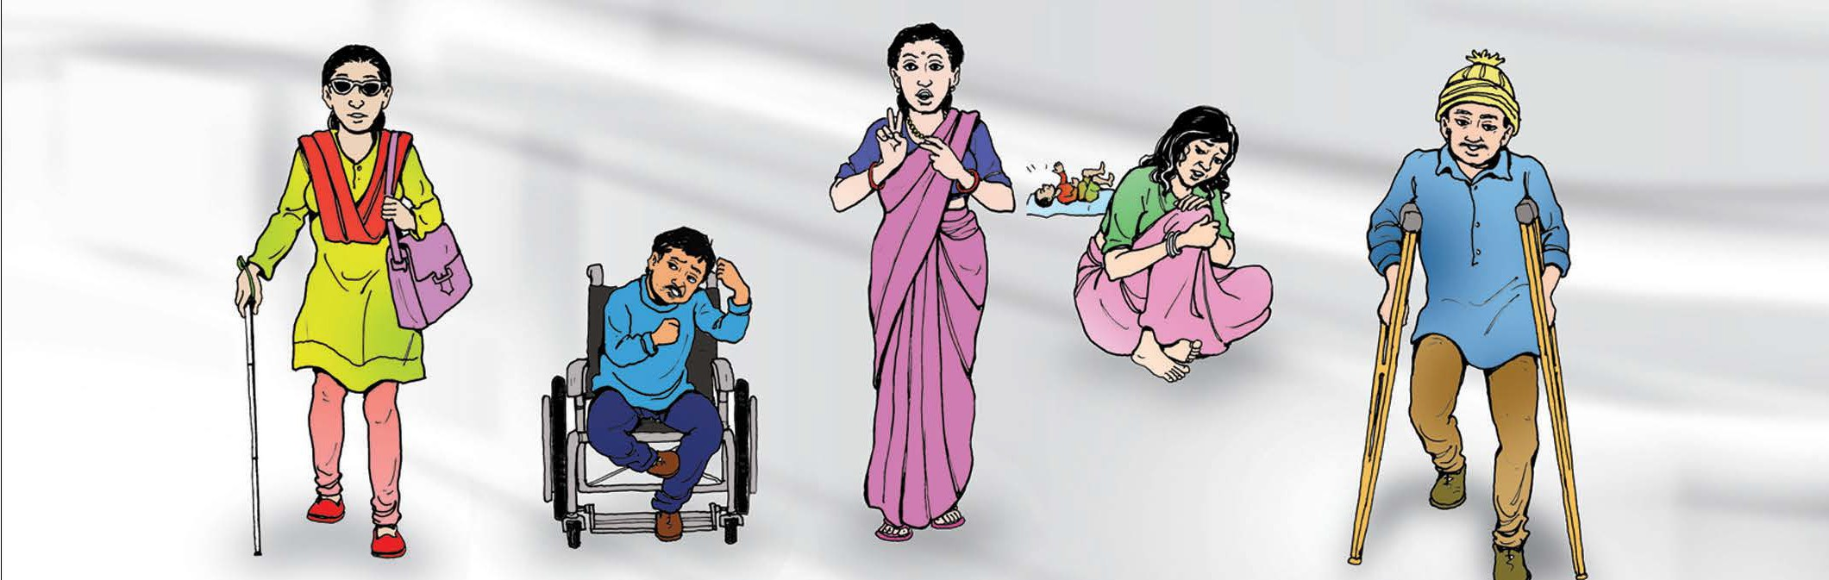
Disability related to hearing:
The impairment caused by the structure of the hearing organs or the inability to identify the sound, its source, rise and fall of volume and the level and quality of the sound is called hearing disability. It is of two types:
  - Deaf: An individual who cannot hear, speaks incoherently or cannot speak and has to use sign language for communication is deaf. In other words, an individual who cannot hear sound above 80 decibels is deaf.
HIRING PERSONS WITH DISABILITIES
  - Hard of Hearing: An individual who can hear a little and cannot talk clearly, can only speak little and needs to use hearing aid is hard of hearing. In other words, an individual who can hear sound between 65 decibels and 80 decibels is hard of hearing.

Deaf-Blind:
An individual who is both hearing disabled and visually impaired is a deaf- blind person.

Disability related to voice and speech:
The impairment arising due to problems in the voice and speech organs or difficulties in rise and fall of volume while speaking, unclear speech, repetition of words and letters is a disability related to voice and speech.

37

Mental Disability:
The inability to behave in accordance with age and situation and delay in intellectual learning due to problems arising in relation to implementation of intellectual activities like problems arising in the brain and mental parts and awareness, orientation, alertness, memory, language, calculation is mental disability.
- Intellectual disability: An individual having difficulty in carrying out activities relative to age or environment due to absence of intellectual development before the age of 18 is intellectually disabled.
- Mental illness: Mental disability is an inability to lead a normal daily life due to mental illness or weakness or deviation.
- Autism: A person who doesn’t show age appropriate normal behaviour since birth, shows abnormal reaction, keeps on repeating same activity, doesn’t socialize with others or shows extreme reaction is considered to be austistic.

Multiple disability:
Multiple disability is a condition of two or more than two types of disability mentioned above.
HIRING PERSONS WITH DISABILITIES

38

Additional Resources

ILO GLOBAL BUSINESS AND DISABILITY NETWORK
http://www.businessanddisability.org
This network is comprised of representatives from multinational enter- prises, employers’ organizations and business networks, and selected non-governmental and disabled peoples’ organizations to assist compa- nies include persons with disabilities in the workforce.

WORLD REPORT ON DISABILITY
http://www.businessanddisability.org/images/pdf/World_report_ Disability.pdf
This document, jointly published by the World Health Organization and the World Bank, reviews evidence about the situation of people with disabilities around the world. For recommendations to the private sector refer to page 269.

JAN: JOB ACCOMMODATION NETWORK
http://askjan.org
JAN website specialized in adapting the workplace for disabled workers is a valuable source of information. Since more than 25 years, JAN assists
HIRING PERSONS WITH DISABILITIES
persons with disabilities improving their abilities in order to be employed. JAN also points out to employers the benefits of hiring disabled workers.

EMPLOYABILITY: A RESOURCE GUIDE ON DISABILITY FOR EMPLOYERS IN ASIA AND THE PACIFIC
http://www.businessanddisability.org/images/pdf/employability.pdf This document contains information to assist businesses and organiza- tions that want to benefit from the business case for recruiting, hiring and retaining persons with disabilities as employees. It presents a collec- tion of resources and examples of good practices.

ILO CODE OF PRACTICE: MANAGING DISABILITY IN THE WORKPLACE
http://www.ilo.org/public/libdoc/ilo/2002/102B09_340_engl.pdf

EARN: Employers Assistance and Resource Network http://www.askearn.org/
The EARN website provides resources and information to help employers recruit, hire, retain and advance individuals with disabilities

39

References

Employing Persons with Disabilities - A guideline for Employers
Published by Better work Indonesia

Guide to Etiquette and Behavior for Relating to Persons With Dis- abilities, 2006
Published by American Friends Service Committee

The Factory Improvement Programme, Disability in the Workplace, Trainer’s Guide, DRAFT
Published by International Labour Organization (ILO)

World Report On Disability, 2011
Published by World Bank and World Health Organization (WHO)

Managing disability in the workplace, 2002
Published by International Labour Organization (ILO)

Job and Work Analysis, Guidelines on Identifying Jobs for Persons with Disabilities, 2005
HIRING PERSONS WITH DISABILITIES
Published by International Labour Organization (ILO)

Employability – A Resource Guide on Disability For Employers in Asia and The Pacific, 2007
Published by International Labour Organization (ILO)

Disability Employment 101
Published by US Department of Education

Recruiting, Hiring, Retaining, and Promoting People with Disabilities
Published by Curb Cuts to the Middle Class Initiative

Hiring People with Disabiltiies: A How to Guide
Pubshiled by United Cerebral Palsy of Central Pennsylvania, Inc.,

40

